Worksheet 3.4: Government All Around

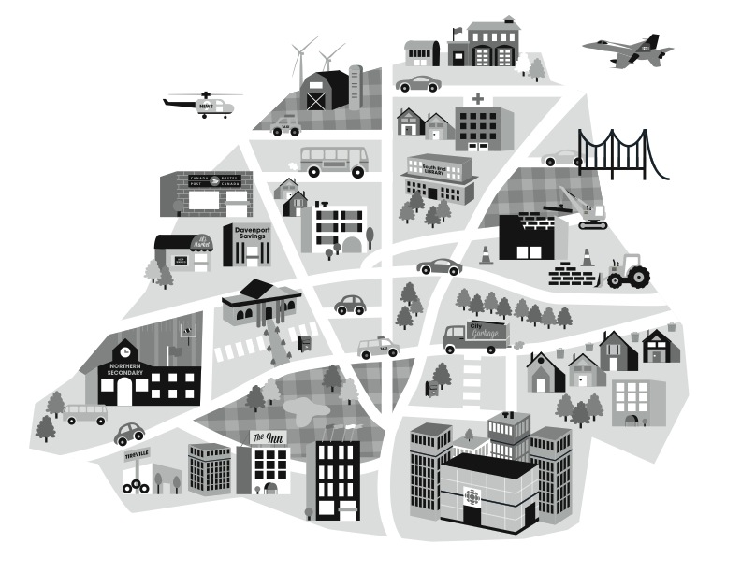
Label government services in the picture below and identify the level of government.

