ACTIVITY 8.3: My Student Vote Learning Experience
Fill in the following visual timeline that depicts your Student Vote learning experience.
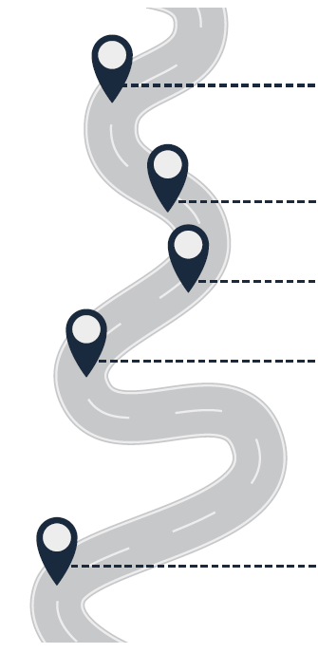 | ONE QUESTION YOU HAD AT THE BEGINNING OF YOUR JOURNEY:
THREE ACTIVITIES YOU ENJOYED DURING
THE ELECTION:
1.

2.

3.

ONE BIG IDEA THAT SUMMARIZES THE
ENTIRE EXPERIENCE:

