ACTIVITY 9.3: Pathway Reflection
Fill in the following visual timeline that depicts your Student Vote learning experience.
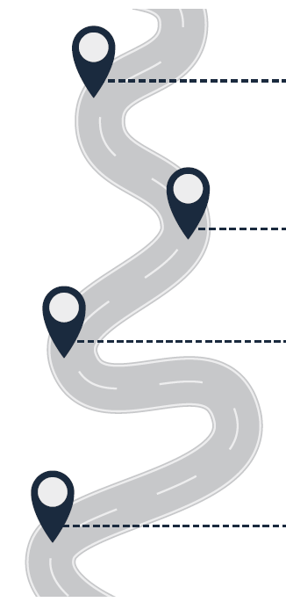 | ONE QUESTION YOU HAD AT THE BEGINNING OF YOUR JOURNEY:
THREE ACTIVITIES YOU ENJOYED IN THE LEAD UP TO STUDENT VOTE DAY

1.

2.

3.

 | ONE ‘A-HA’ MOMENT:
 | ONE BIG IDEA THAT SUMMARIZES THE ENTIRE EXPERIENCE:

