**Activity 2.5: Equality, Equity and Justice**

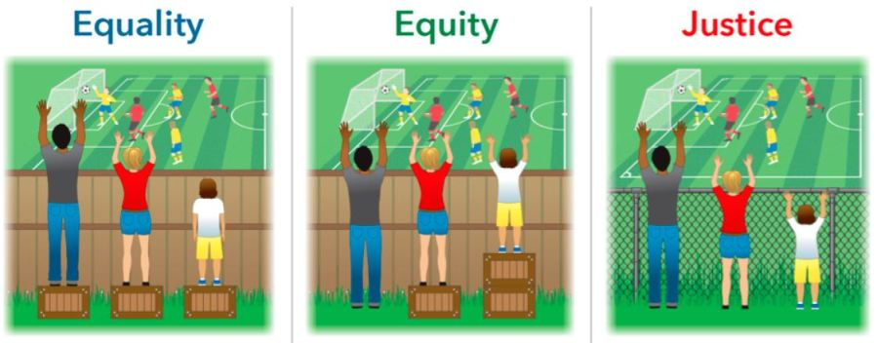

_____________________________________________________________________________________

**1. Analyze the images above and explain the differences.**

_____________________________________________________________________________________

**2. Describe equality, equity and justice in your own words.**

|  |  |
| --- | --- |
| **Equality** |  |
| **Equity** |  |
| **Justice** |  |

_____________________________________________________________________________________

**3. Can you provide examples of each within our school?**