**Handout 2.1: Design Your Toronto**

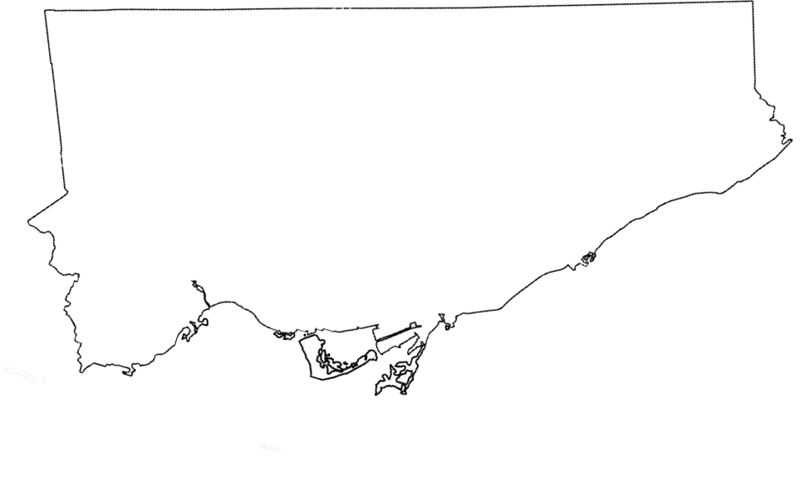

**Design Your Neighbourhood**